

**Enterprise Web Software Development**

**Comp 1640**

Team members:

Nguyễn Minh Triết

Nguyễn Huy Nhật Tân

Đỗ Thành Đạt

Trần Tuấn Thành

Phạm Mai Nhật trường

**Table of Contents**

Contents

1. Project Introduction 4
2. ERD diagram 5
3. Relational Schema 5
4. Use case diagram 6
5. Activity diagram 9
6. Sitemap 13
7. Design. 18
8. Testing 18
9. Agile Method: Product Backlogs, Sprint Backlogs, Schedule, Progress, Daily Meetings, Sprint Review & Retrospective Meetings, Burndown Charts 25
10. Product: Screenshots of your actual application and its functions. 27
11. Links: Source Codes (Github), Screencast (Youtube/Google Drive/Onedrive) 27
12. References. 27

**List of Figure**

**Group Report**

# Project Introduction

The web-based system with secure role-based mechanism that collects student contributions for a yearly university magazine is to be essential and since it is through this that the magazine production process will be improved in the university. The mission of the Marketing Manager is to provide on-going support and supervision as each Faculty is supplied with a Marketing Coordinator who is in charge of administration and editorial creativity of their respective departments. Under the guidance, system, all of the students can submit their ideas and aesthetic images, which will build up a fair and comprehensive thematic publication. By limiting the submission dates to agreed dates of closure and giving updates until the original closure date, the system can guide the work through a managed process and an efficient system. Furthermore, the Terms and Conditions agreement which takes care of compliance and uses statistics for better surveillance is implemented during the course of the submission process. Through automatic email notifications, Marketing Coordinators are immediately informed of the appearance of new submissions and are tasked with responding to them within the range of a given timeframe. Beyond that, by designing this method, the System Assistants can help "Students", be "Edited" and "Published", which consequently promotes communication and the interaction of both parties, thus giving birth to cooperation. The university marketing manager has the access to all contributions but s/he cannot edit the messages, therefore connects dots between marketing strategies. In addition, administrator maintains system data such as academic years closing dates, while guest accounts that students use to study are able to see only particular reports for all Faculty depending on permissions. The system has been equipped with statistical analysis capabilities as well as a user-friendly interface designed to work on all devices. The platform thereby ensures transparency, efficiency and inclusion for everyone involved in the magazine publication process.

# ERD diagram

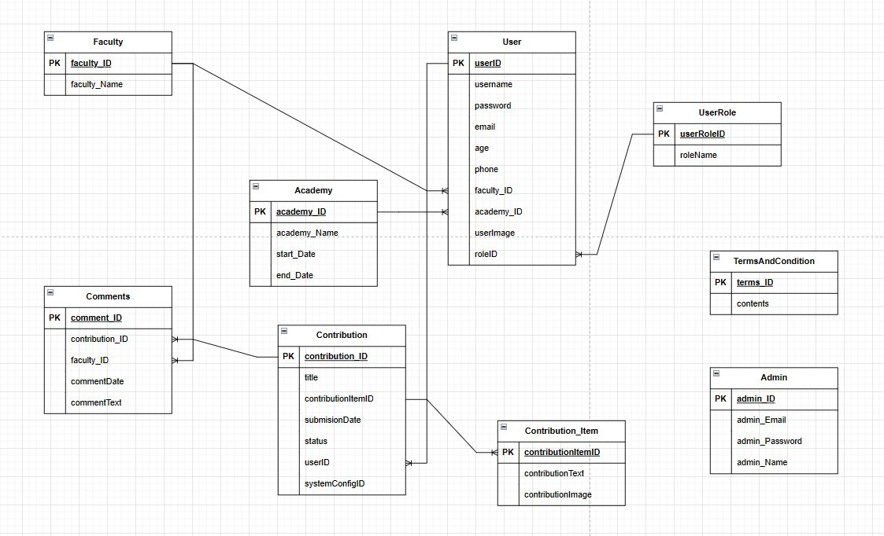

# Relational Schema

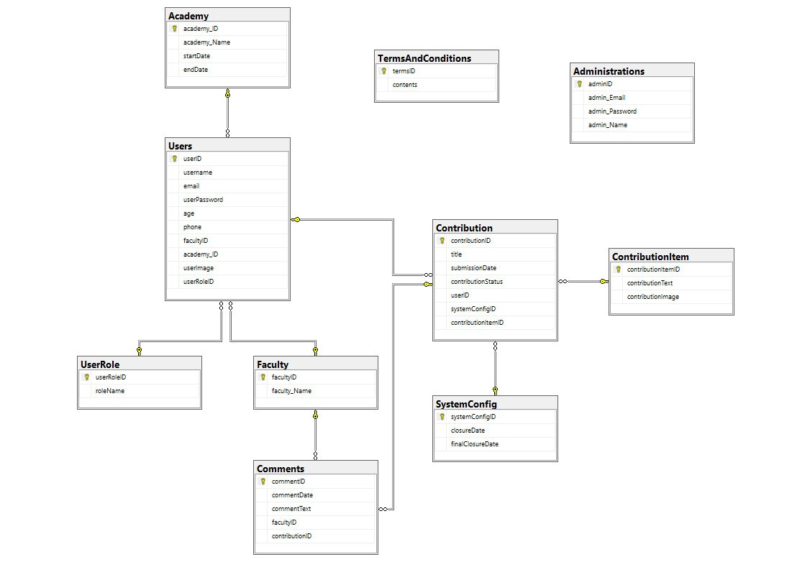

# Use case diagram

Use case of student

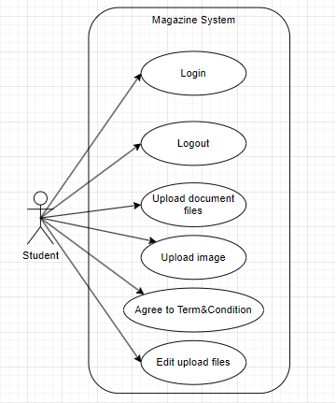

Use case of marketing coordinator

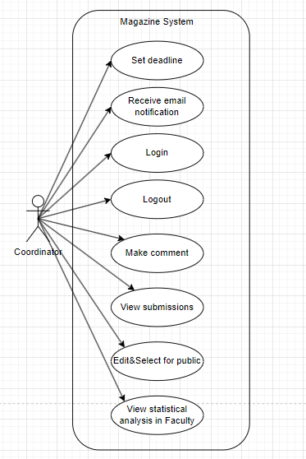

Use case of marketing manager

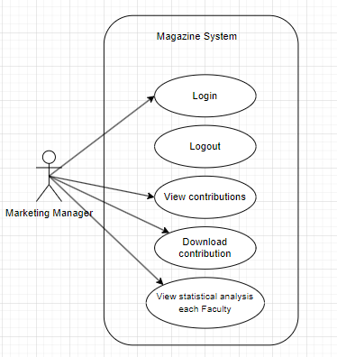

Use case of Admin

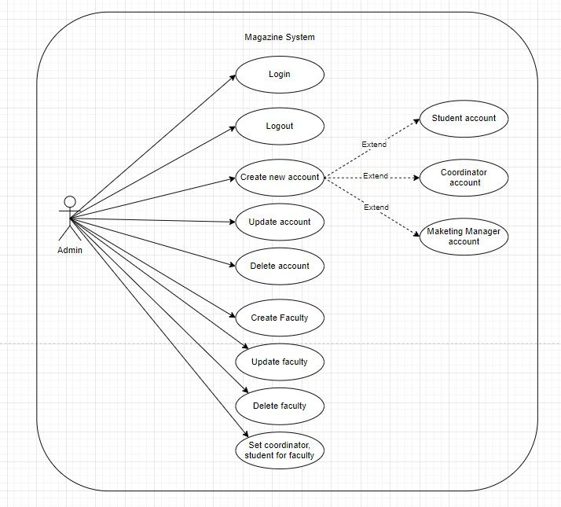

# Activity diagram

The activity diagram of Students shows a stepwise approach that begins with a student login. After inputting its details, the system authenticates itself. If the student is resourceful, he/she can download an image or document after a successful submission. Authentication error is displayed and let the retry is an option to log in. Finally irrespective of student's status of the authentication the student eventually logs out.

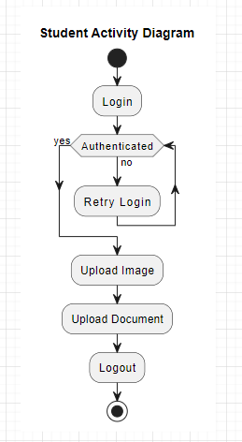

The coordinator activity diagram clearly describes the sequence that the coordinator should follow to try logging into the system. After logging in with the system, it checks if given access is approved to the coordinator. If successful, the coordinator of the petitions becomes the owner of a few duties, namely reading in entries, editing the written contributions, leaving comments, and publication of the submissions. Should the authentication fail, the system will display information on how to do the same action again. Finally, the coordinator logs out, where authentication issue ceases to matter.

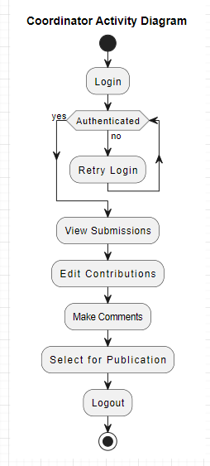

This activity diagram shows what a marketing manager goes through to bring together ideas and hand them over to the departments concerned. The supervisor opens the system and sees a list from which he can separately select the contributions, by several methods. This would enable them to pick contributions of their choice and download them for further examination. Use our AI to write for you about any topic! Enjoy Ultimately, upon finishing the review stage, the employee logs out of the online system. This diagram can be used to comprehend the workflow of the process, but it does not pinpoint exact channels or any constraints.

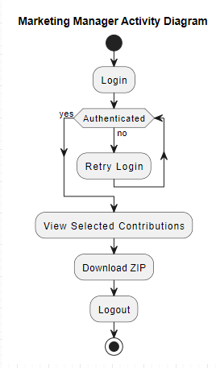

The Admin Activity Diagram reveals how an admin navigates the system after providing a login. In the first step the user enter a name and password which will be inspected for authentication. After that, the admin can leverage the data in the system to view reports, manage accounts and publications, and finally log out. Another security feature that logins include is passphrase failure. In this case, the admin can proceed to retry the login process.

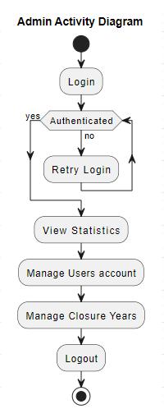

# Sitemap

The website map drawn below provides the framework of the site by revealing its pages and directories. It contributes to the success of a website by both guiding users to the desired content and supporting search engine indexing. Webpages would include Home, About Us, Contact Us, Login, Create Account, Edit Account, Delete Account, Account Management, Admin Panel, Closing Day, Academy, Students, Marketing Management, Guest Invitation, Submitting and Viewing comments, Accessing contributions and Commenting contributions. On our web page, the highlight is links between pages and directories such as Home and About Us, Contact Us, Login, Create Account, and Account Management demonstrating a well desirable structure.

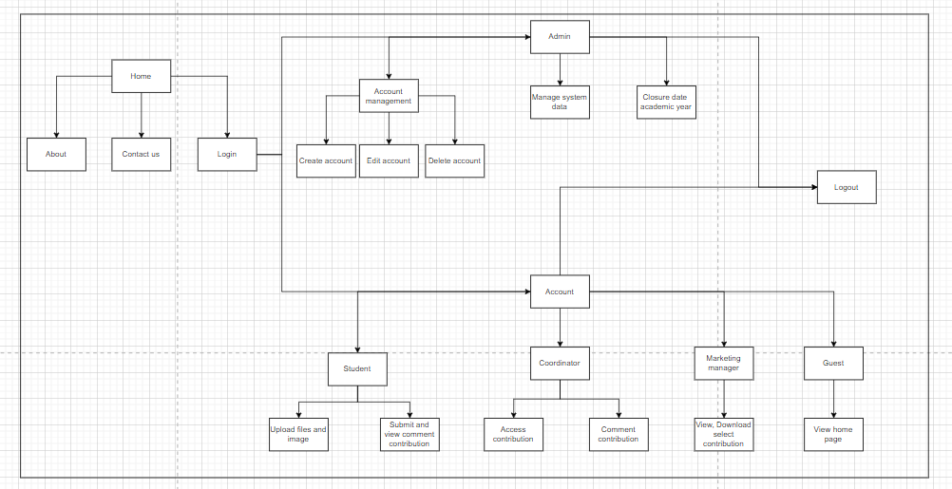

Admin sitemap

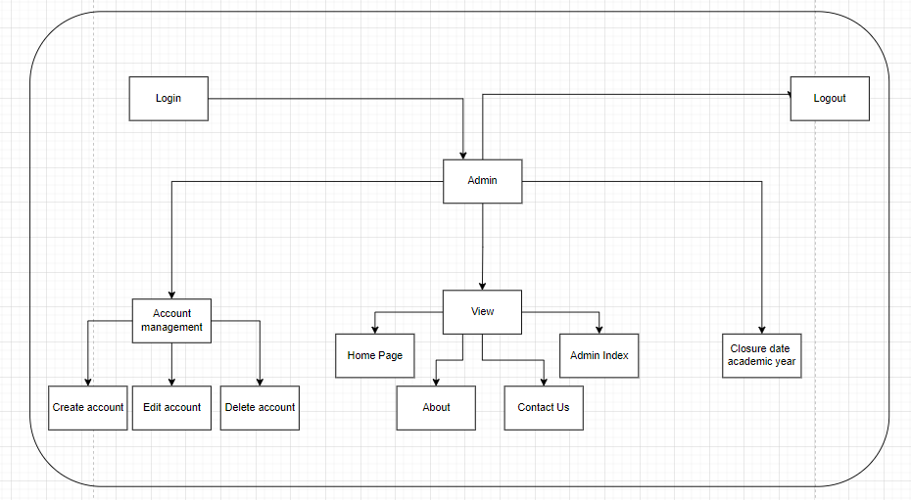

Student sitemap

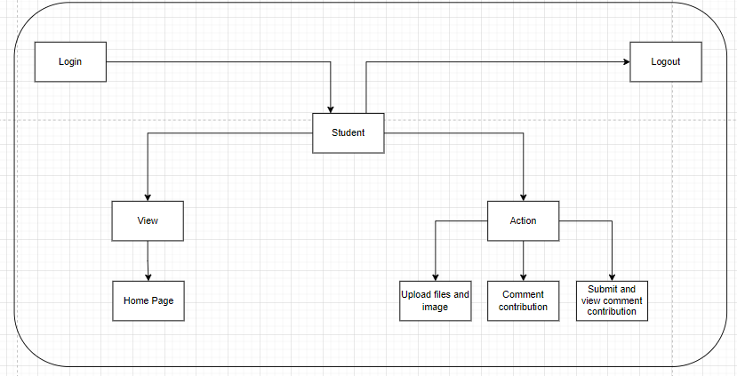

Marketing Coordinator

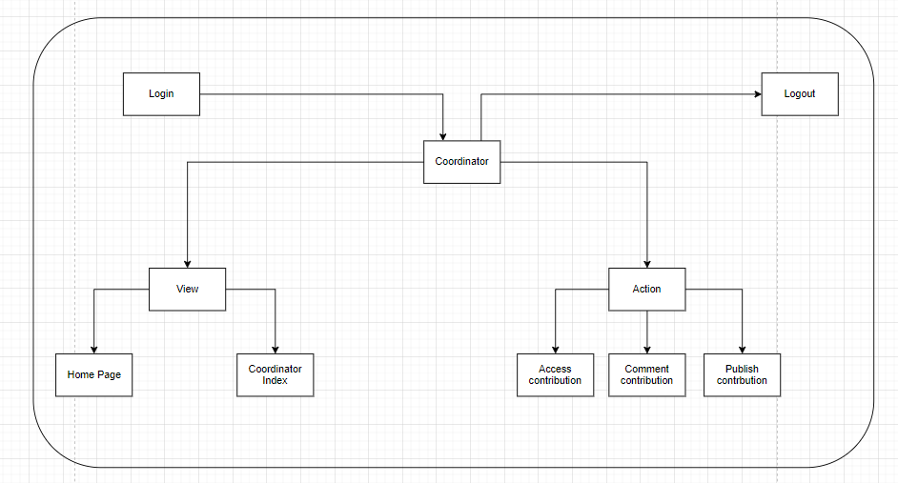

Marketing Manager

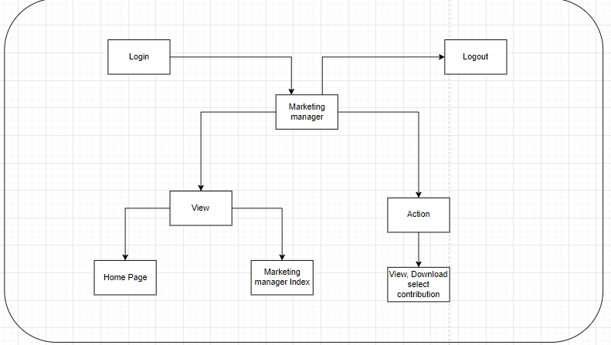

1. Sequence diagram

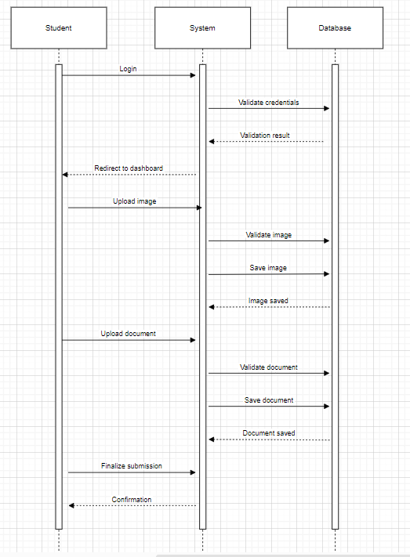

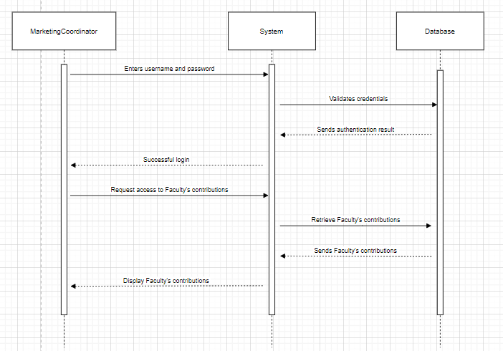

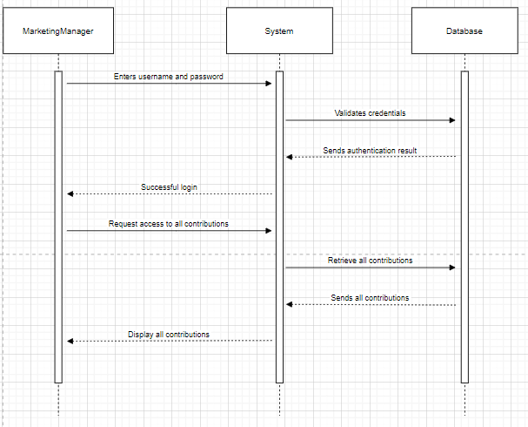

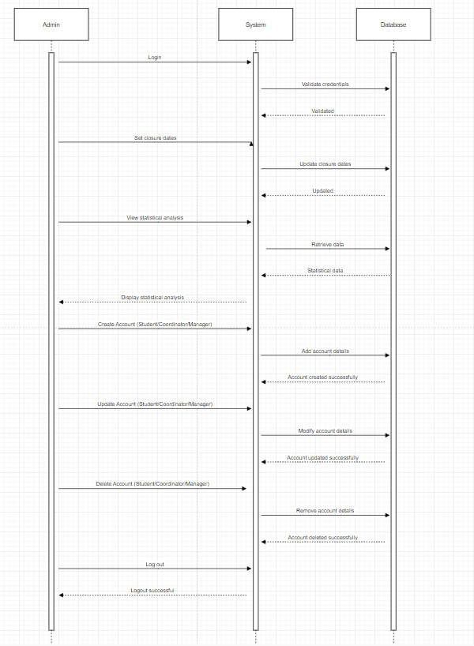

# Design

# Testing

|  |  |  |  |  |  |
| --- | --- | --- | --- | --- | --- |
| No. | Function | How to test | Expected test results | Actual test  results | Pass /  Fail |
|  | Login to system | Login by Admin account  Name: [admin@gmail.com](mailto:admin@gmail.com)  Pass: 1234567 | Login successful | Login successful | Pass |
|  | Logout to system | Logout by Admin account | Logout successful | Logout successful | Pass |
|  | Create student account | Input Information  Name: Test 1  Gmail: [Test1@gmail.com](mailto:Test@gmail.com)  Faculty: Design  Password: 1234567  Gender: Male  Image: Test1.jpg  City: Ho Chi Minh  Phone: 001  Role: Student | Create student account name Test 1 | Create student account name Test 1 successful | Pass |
|  | Create student account | Input Information  Name: Test 2  Gmail: [Test2@gmail.com](mailto:Test@gmail.com)  Faculty: Computing  Password: 1234567  Gender: Male  Image: Test2.jpg  City: Ho Chi Minh  Phone: 002  Role: Student | Create student account name Test 2 | Create student account name Test 2 successful | Pass |
|  | Create student account | Input Information  Name: Test 3  Gmail: [Test3@gmail.com](mailto:Test@gmail.com)  Faculty: Business  Password: 1234567  Gender: Female  Image : Test3.jpg  City : Ho Chi Minh  Phone : 001  Role : Student | Create student account name Test 3 | Create student account name Test 3 successful | Pass |
|  | Re-create an existing student account | Input Information  Name : Test 1  Gmail: [Test1@gmail.com](mailto:Test@gmail.com)  Faculty : Business  Password: 1234567  Gender : Female  Image : Test1.jpg  City : Ho Chi Minh  Phone : 001  Role : Student | Notification that the account already exists | Notification that the account already exists | Pass |
|  | Create student account | Input Information  Name : Test 4  Faculty : Business  Password: 1234567  Gender : Female  Image : Test4.jpg  City : Ho Chi Minh  Phone : 004  Role : Student | Do not add an account without enough information | Notice that information is missing and must be supplemented if you want to add an account | Pass |
|  | Create marketing manager account | Input Information  Name: Marketing Manager 1  Faculty: Business  Password: 1234567  Gender: Female  Image: manager1.jpg  City: Ho Chi Minh  Phone: 12345  Role: Manager | Create marketing manager account name Marketing Manager 1 | Create marketing manager account name Marketing Manager 1 successful | Pass |
|  | Create marketing manager account | Input Information  Name: Marketing Manager 2  Faculty: Business  Password: 1234567  Gender: Female  Image: manager2.jpg  City: Ho Chi Minh  Phone: 12345  Role: Manager | Phone number information is duplicated and must be re-entered | Re-entered phone number information successfully | Pass |
|  | Create Coordinator account | Input Information  Name: Coordinator 1  Faculty: Business  Password: 1234567  Gender: Female  Image: coordinator1.jpg  City: Ho Chi Minh  Phone: 0008  Role: coordinator | Create coordinator account name Coordinator 1 | Create coordinator account name Coordinator 1 successful | Pass |
|  | Edit account student | Edit account student  Name: Test 1 => Test 1 new | Update account student | Update account student successful | Pass |
|  | Edit account student | Edit account student  Name: Test 1 new  Gmail: Test1gmail.com  => test@gmail.com  Account is duplicated: Name test  Gmail: test@gmail.com | Edit an existing student gmail account that overlaps with another account | Notice of duplicate gmail and request to re-enter | Pass |
|  | Update image student | Update account student  Name: Test 1 new | Update new image | Update new image successful | Pass |
|  | Update image marketing manager | Update account marketing manager  Name: Marketing Manager 1 | Update new image | Update new image successful | Pass |
|  | Update image coordinator | Update account coordinator  Name: Coordinator | Update new image | Update new image successful | Pass |
|  | Delete account student | Delete account student  Name: Test 1 new | Delete account student | Delete account studen007 successful | Pass |
|  | Delete marketing manager account | Delete account Marketing Manager  Name: Marketing Manager 1 | Delete account marketing manager | Delete account marketing manager successful | Pass |
|  | Delete coordinator account | Delete account coordinator  Name: Coordinator | Delete account coordinator | Delete account coordinator successful | Pass |
|  | Check Terms and Conditions before submit contribution | Terms and Conditions: You must agree to the user terms | If not check the box before submit will pop up alert | Check the box before submit contribution and contribution submit successful | Pass |
|  | Create Academy | Input information Academy  Name: test academy  Description: test academy Start date: 7/4/2024  End date: 10/4/2024 | Create Academy | Create Academy successful | Pass |
|  | Edit name Academy | Edit information Academy  Id: 03  Name: test academe  => test academe new  Description: test academe Start date: 7/4/2024  End date: 10/4/2024 | Edit name Academy | Edit Name Academy successful | Pass |
|  | Delete Academy | Delete information Academy  Id: 03  Name: test academy new  Description: test academy Start date: 7/4/2024  End date: 10/4/2024 | Delete Academy | Delete Academy successful | Pass |
|  | Login account student | Login account student name Test 1 | Login successful | Login successful | Pass |
|  | Check academy | Academy is still valid | Blogs can be added | Successful | Pass |
|  | Check academy | Academy is no longer valid | Cannot add blog | Successful | Pass |
|  | Submit contribution | Input information in submission form  Title: Blog test1  Content: Blog test1  Upload Background Image:  Test1.jpg  Upload File: testaddblog.docx  Click box: terms and conditions | Submit contribution successful | Submit contribution successful | Pass |
|  | Submit contribution | Input information in submission form  Title: Blog test2  Content: Blog test2  Upload Background Image:  Test2.jpg  Upload File: testaddblog.docx  Click box: terms and conditions | Submit contribution successful | Submit contribution successful | Pass |
|  | Logout account student | Logout account student name Test 1 | Logout successful | Logout successful | Pass |
|  | Login account coordinator | Login account coordinator name Coordinator 1 | Login successful | Login successful | Pass |
|  | Comments in student contribution | comment on contribution name: Blog test 1 | Comment contribution successful | Comment contribution successful | Pass |
|  | Logout coordinator account | Logout account coordinator name Coordinator 1 | Logout successful | Logout successful | Pass |
|  | Login marketing manager account | Login account marketing manager name Marketing Manager 1 | Login successful | Login successful | Pass |
|  | Create guest account | In marketing manager account create guest account  Input gmail, name, password, phonenumber, image, city | Create guest account | Create guest account successful | Pass |
|  | Edit guest account | In marketing manager account create guest account  Guest account information can be edited | Edit guest account | Edit guest account successful | Pass |
|  | Delete guest account | In marketing manager account create guest account  Guest account information can be deleted | Delete guest account | Delete guest account successful | Pass |
|  | Download contribution | Download published contribution | Download  successful | Download contribution successful | Pass |
|  | Logout account marketing manager | Logout account marketing manager name Marketing Manager 1 | Logout successful | Logout successful | Pass |

1. Agile Method: Product Backlogs, Sprint Backlogs, Schedule, Progress, Daily Meetings, Sprint Review & Retrospective Meetings, Burndown Charts

Sprint 1

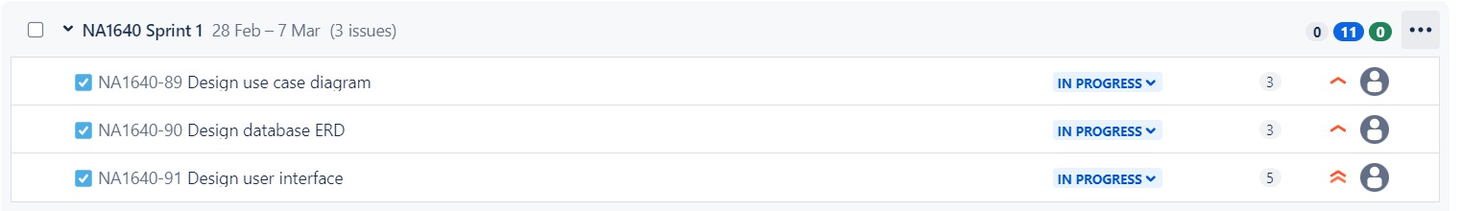

Sprint 2

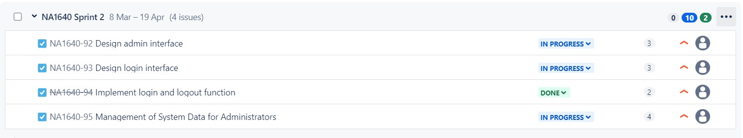

Sprint 3

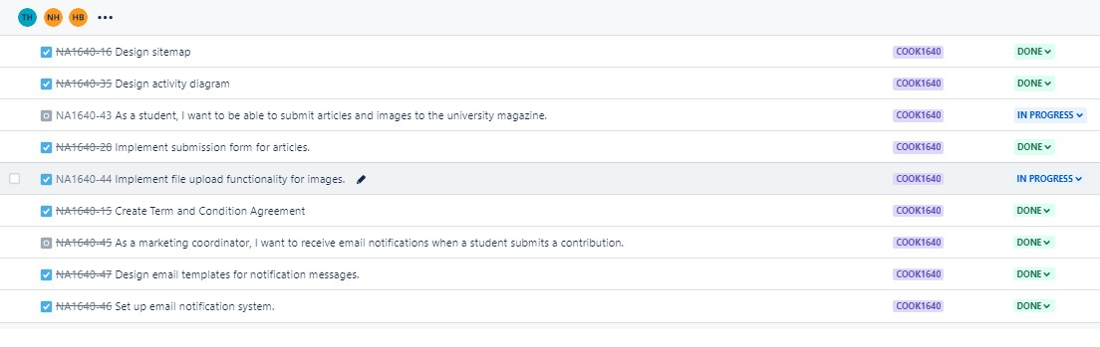

Sprint 4

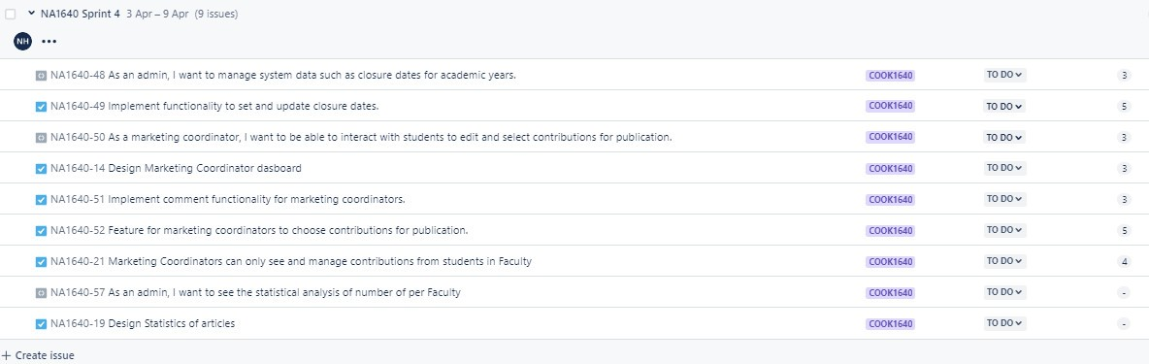

Sprint 5

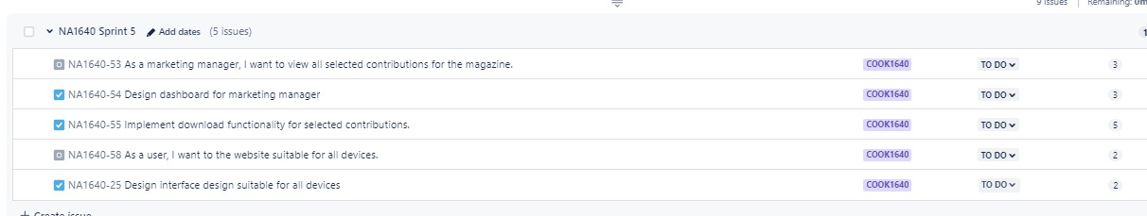

Burndown chart

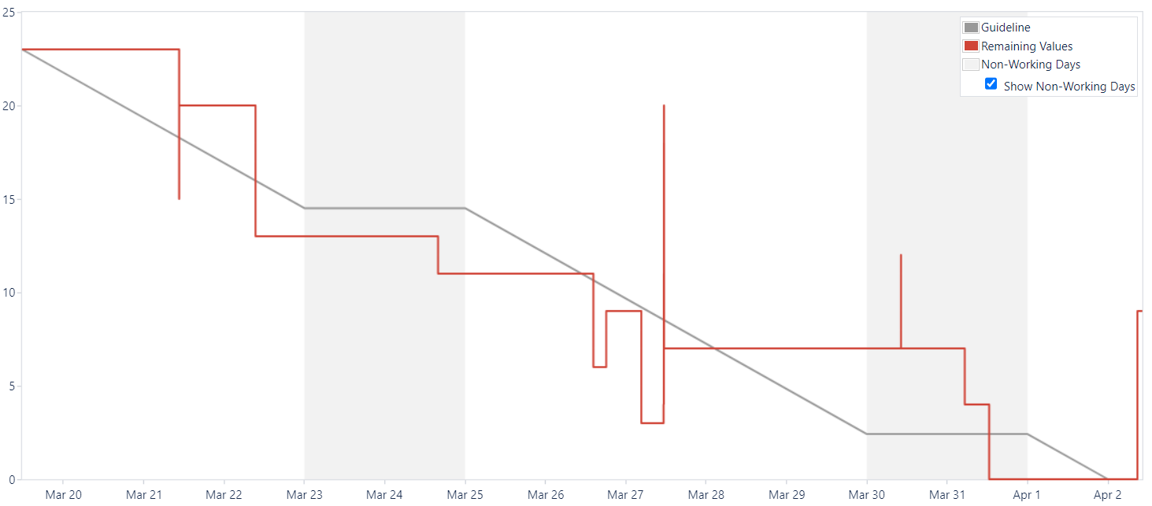

# Product: Screenshots of your actual application and its functions

Admin home page

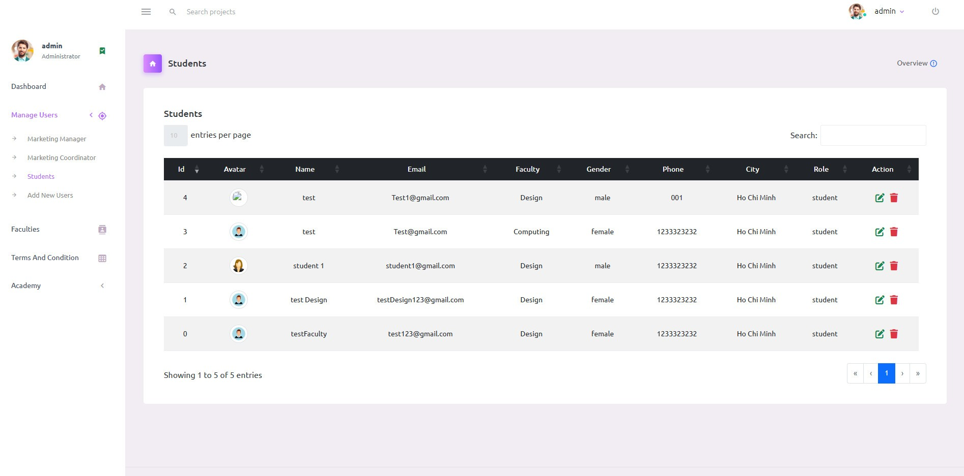

Admin add account page

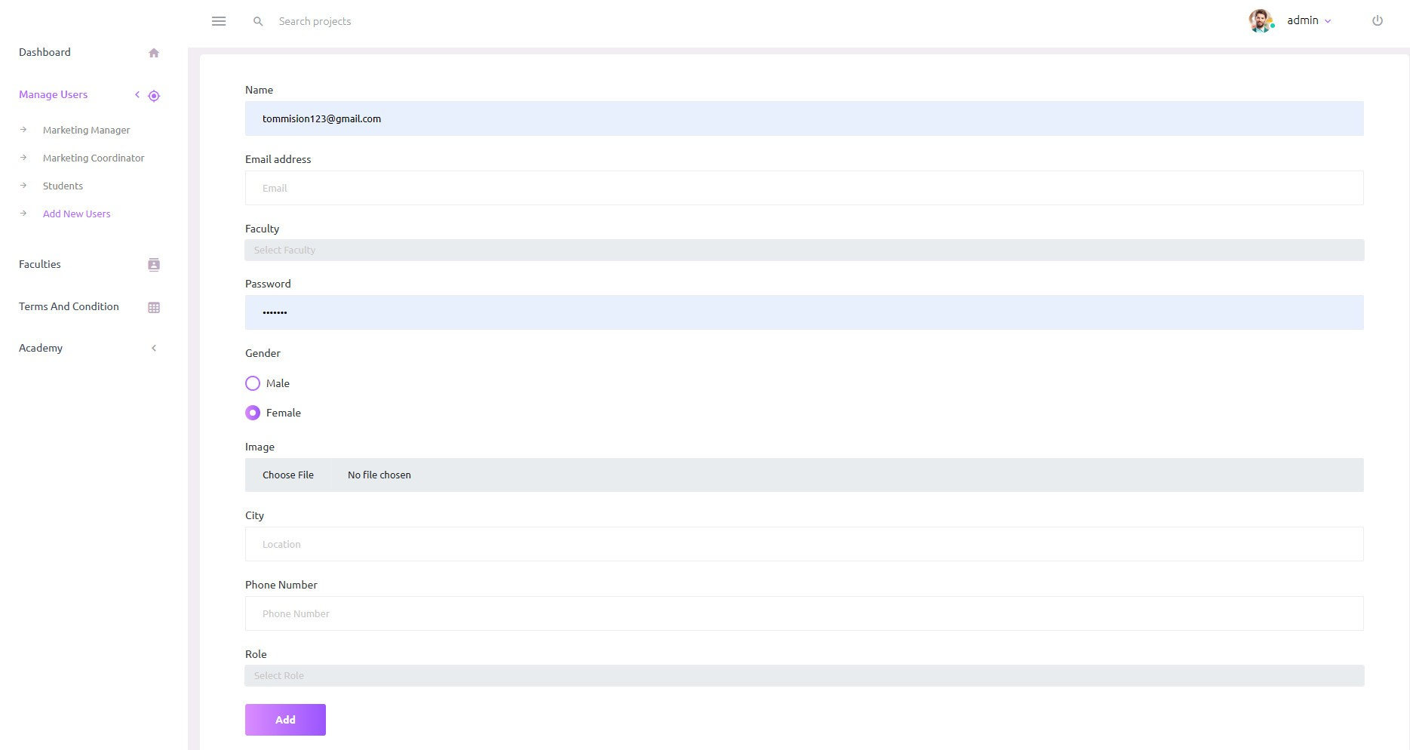

Admin manage the Academy year

Marketing coordinator home page

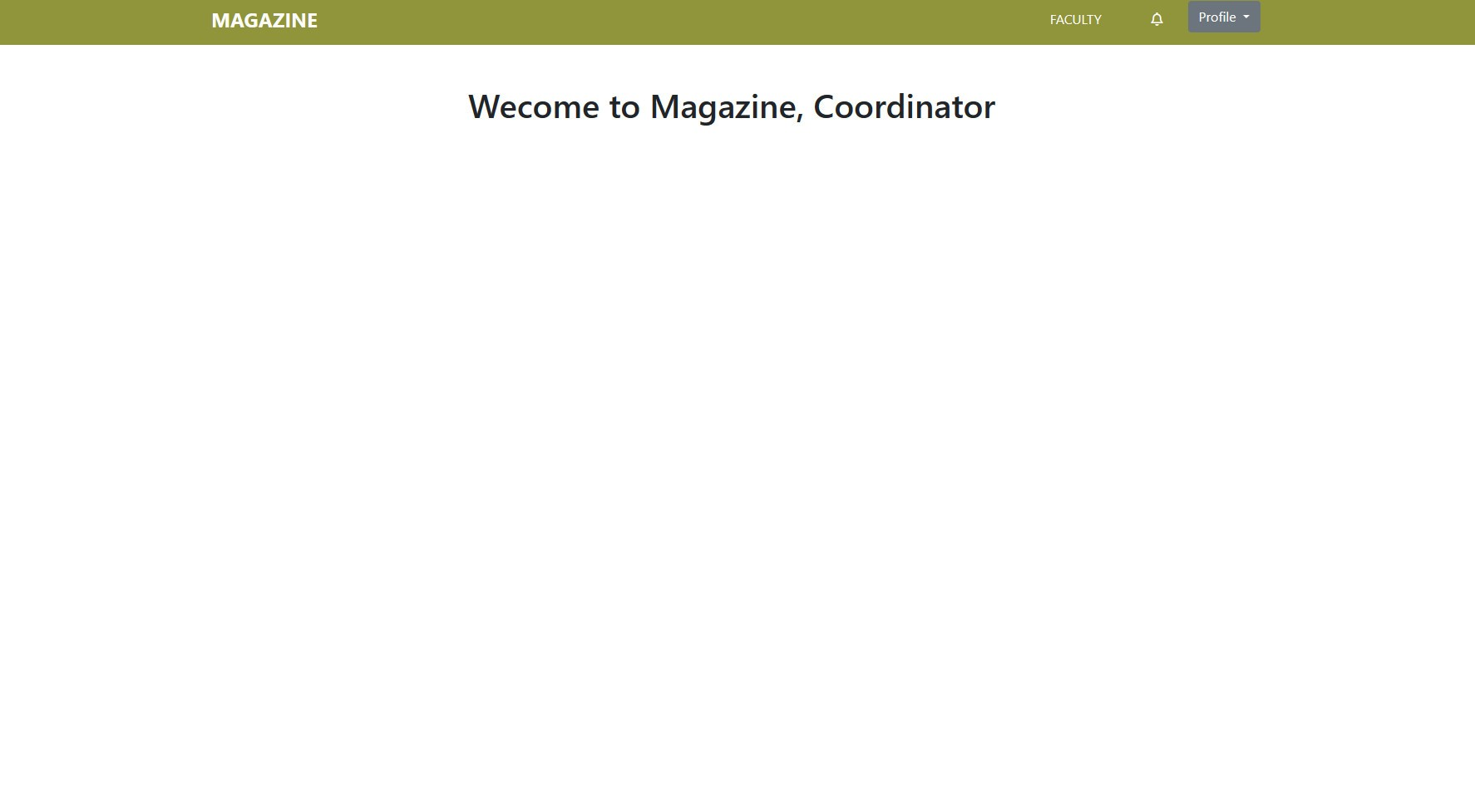

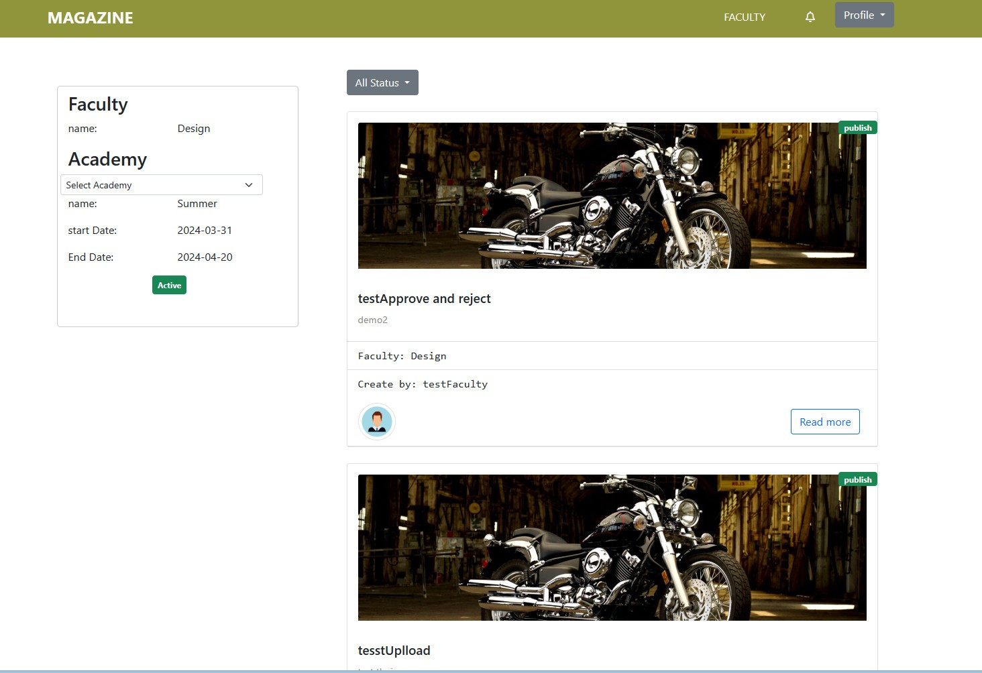

Contribution detail page

Marketing coordinator oversee the contribution of student

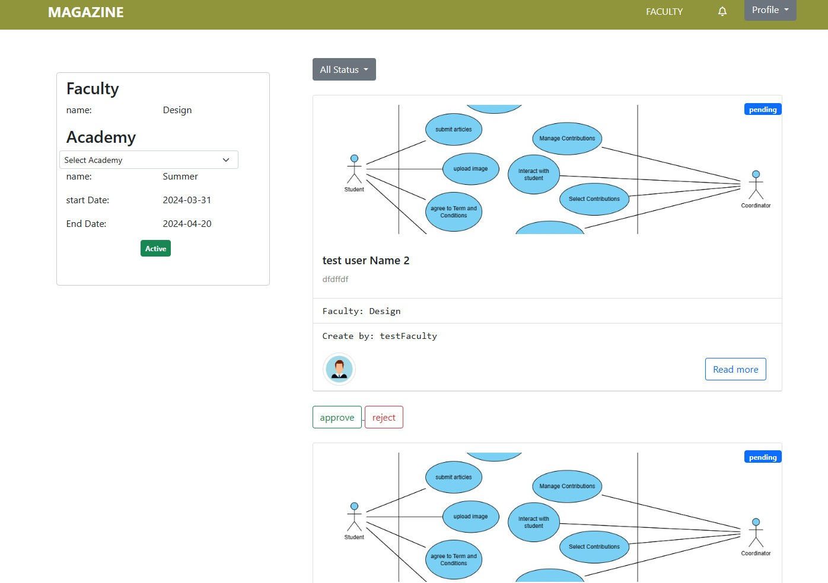

Marketing profile page

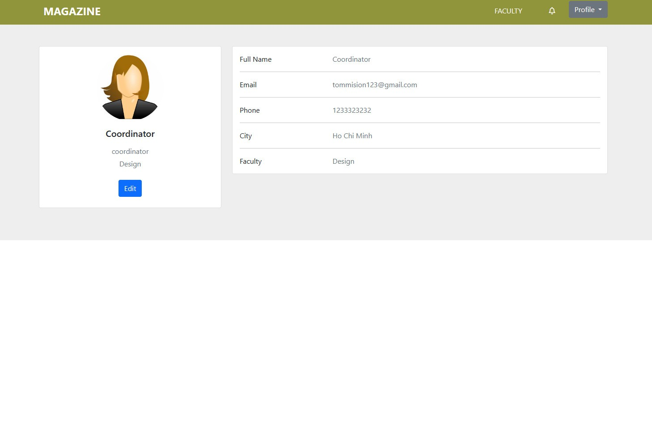

Login page



Management list guest account

Add new guest account

Home page for Guest

Guest view the published contributions

# Links: Source Codes (Github), Screencast (Youtube/Google Drive/Onedrive)

# References: